# Chapter 5: Testing

Software testing is an activity to check whether the actual result match with the expected result. It involves execution of software components or system components to evaluate project. It helps to identify errors, gap, requirement etc. The types of software testing I will be using for the book reading system are: White box testing and black box testing. The main reasons to do testing is to reduce bugs which may cause harm and loss to the Book reading system.

## 1. White box testing.

It is the testing which involves the system, means the testing done to system components or code to compare the actual result and expected result. Since I have used Java as programming language to develop Book reading system. I have used Mockito for unit testing or white box testing because it is effective for Java application and it creates a dummy functionality which can be added to mock interface and use in unit testing.

The test plan for Unit testing of Book reader is shown below:

|  |  |  |  |  |  |
| --- | --- | --- | --- | --- | --- |
| S N | Test Case | Data | Expected | Actual Result | Date of testing |
| 1. | Should Show Error Message When Username Is Null | Null | Error message about username | Error message about username | 2019/7/1 |
| 2. | Should Show Error Message When Password Is Null | Username=Ninzen  Password=null | Error message about password | Error message about password | 2019/7/1 |
| 3. | Go To Dashboard When Username And Password Is Correct | Username=Ninzen  Password=password | Login successfully Goes to Dashboard activity | Login successfully Goes to Dashboard activity | 2019/7/1 |
| 4. | Show Error Message When Username or Password Is Incorrect | Username=123  Password=pass123 | Invalid username or password Error message | Invalid username or password Error message | 2019/7/1 |
| 5. | Should Show Error Message When Full Name Is Null When Creating New Account | Null | Error message to enter name | Error message to enter name | 2019/7/1 |
| 6. | Should Show Error Message When Email Is Null When Creating New Account | Name= Ninzen lama  Email =null | Error message to enter Email | Error message to enter Email | 2019/7/1 |
| 7. | Should Show Error Message When Email Is Not Valid When Creating New Account | Name = Ninzen lama  Email= ninzen.com | Error message to use a valid email | Error message to use a valid email | 2019/7/1 |
| 8. | Should Show Error Message When DOB Is Null When Creating New Account | Name =Ninzen lama  Email = [Ninzenlama21@gmail.com](mailto:Ninzenlama21@gmail.com)  Data of birth =null | Error message to enter date of birth | Error message to enter date of birth | 2019/7/1 |
| 9. | Should show error message when password is null when creating new account | Name = Ninzen lama  Email= [ninzenlama21@gmail.com](mailto:ninzenlama21@gmail.com)  Data of birth = 1999/08/23  Username = Ninzen  Password = null | Error message to enter password whole creating new user | Error message to enter password while creating new user | 2019/7/1 |
| 10. | Should show when Author is null | Title=Compute project  Author =Null | Error message to enter Author | Error message to enter Author while adding book | 2019/7/1 |
| 11. | Should show error message while publisher is null | Title = Computer project  Author = Ninjeng lama  Publisher = null | Show error message when publisher is null | Show error message when Publisher is null | 2019/7/1 |

The unit testing in android studio.

1. Test result of the unit testing.

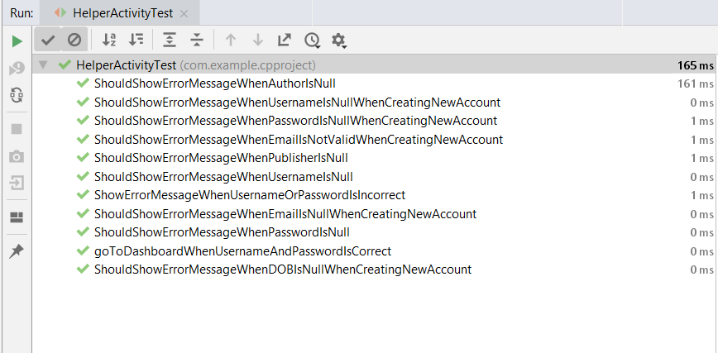

1. Helper Activity Test

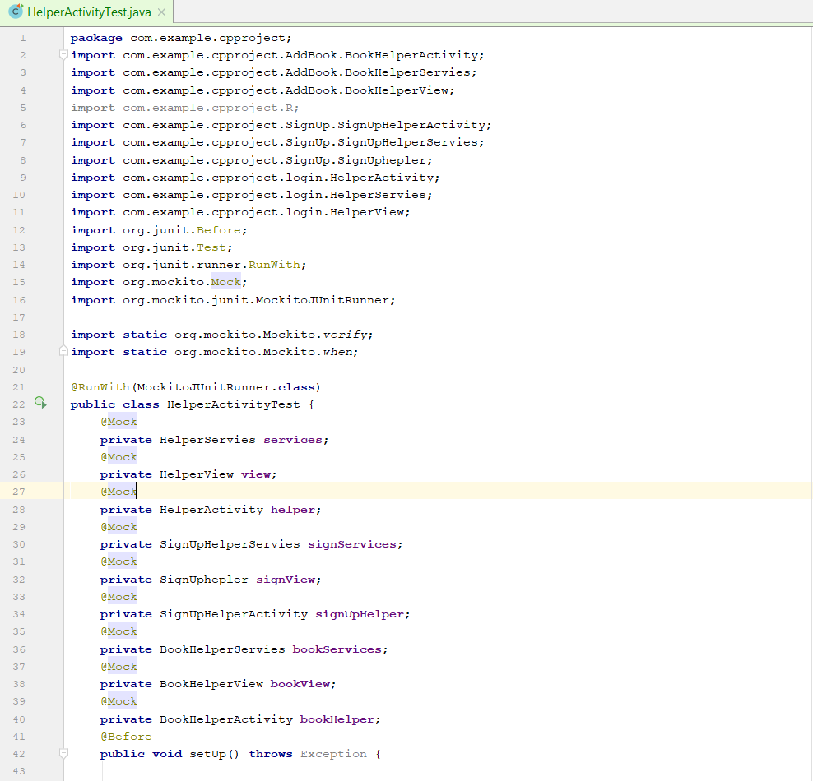

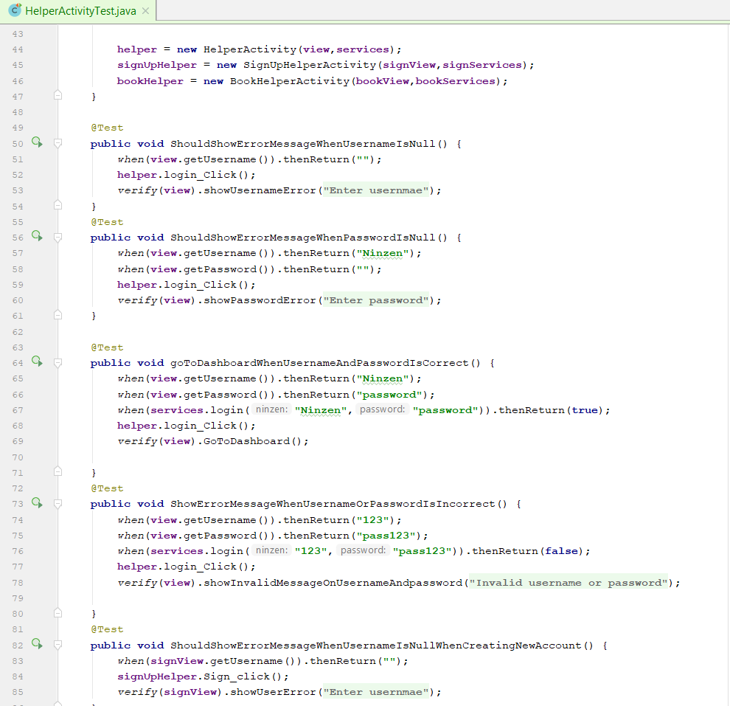

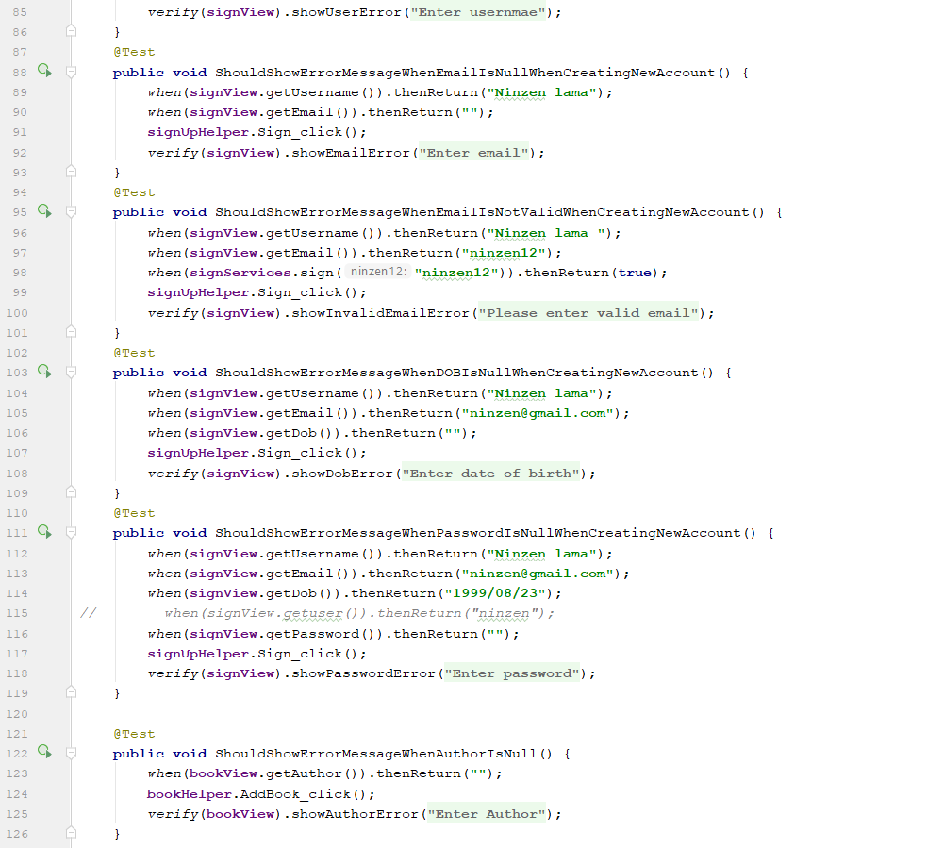

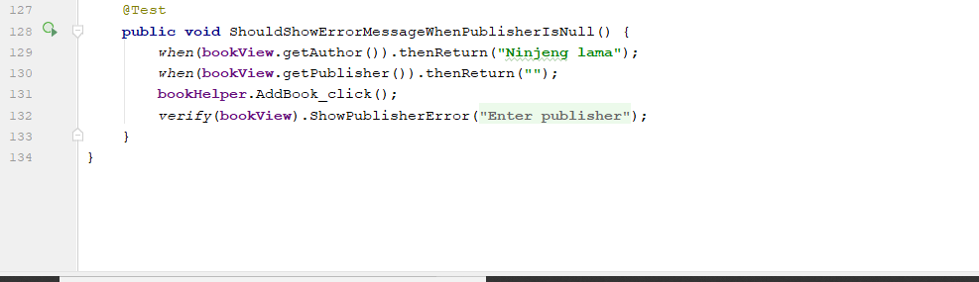

1. The Activity and interface used in Unit testing
2. Login

1.1 Helper Activity

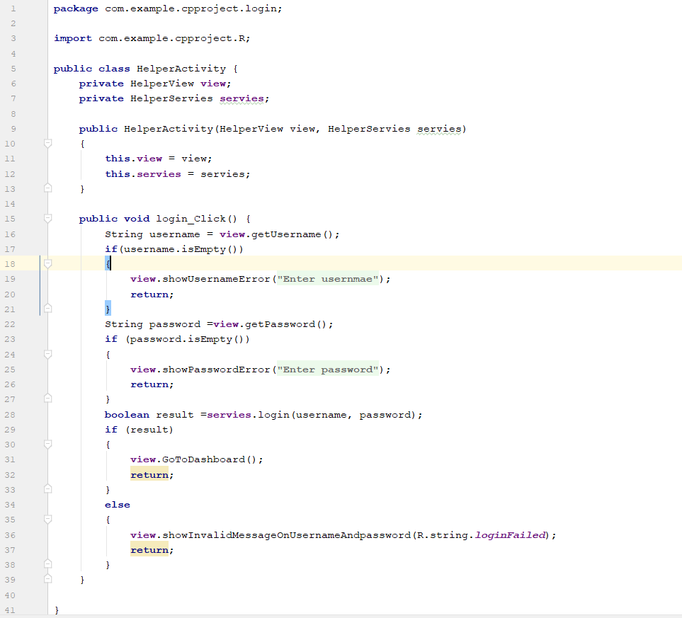

* 1. Helper services

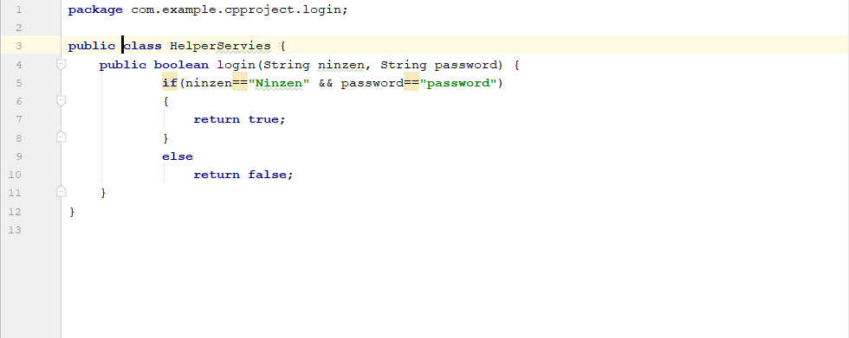

* 1. Helper View (Interface)

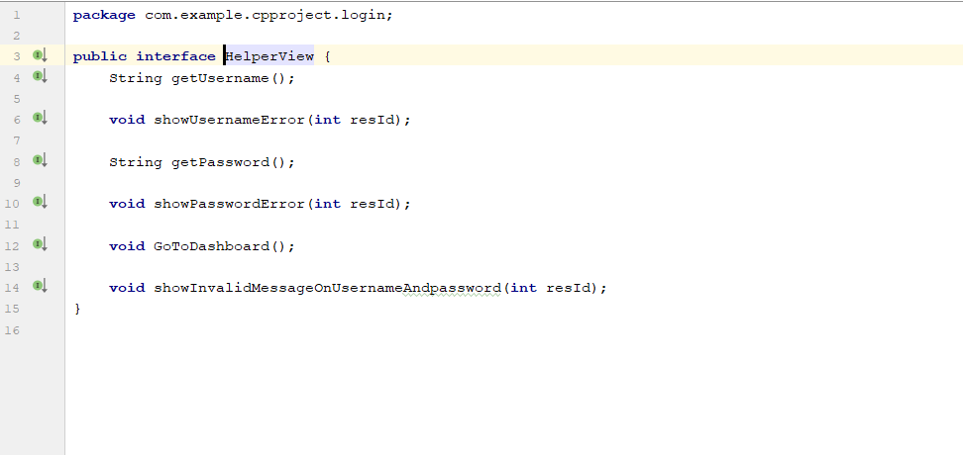

1. Sign
   1. Signup helper activity

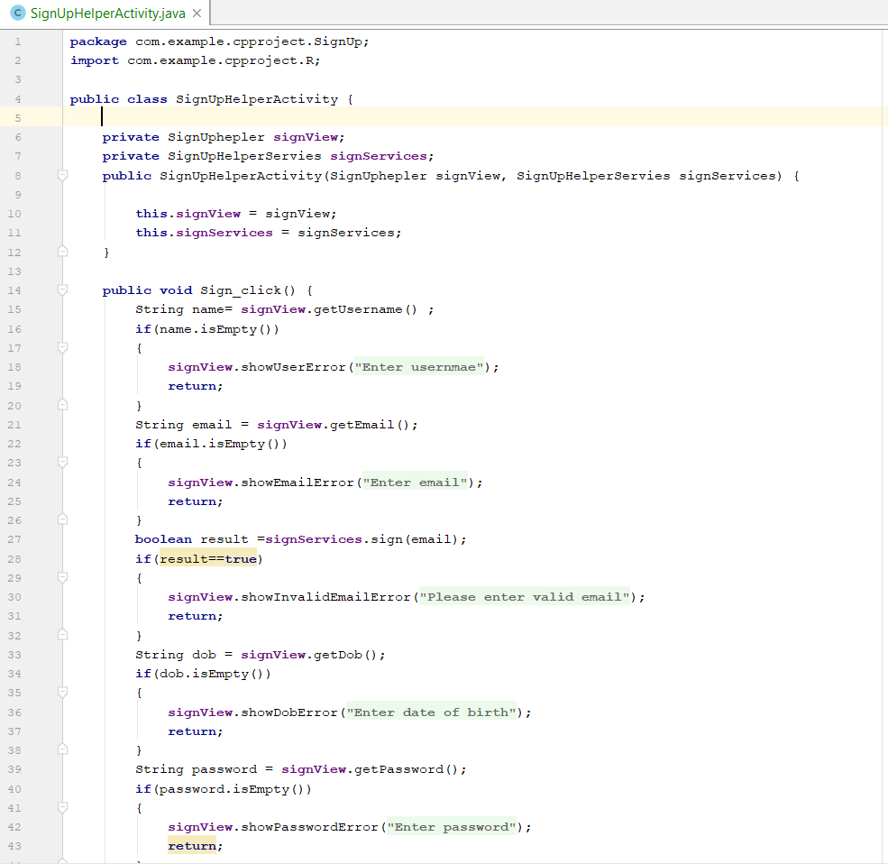

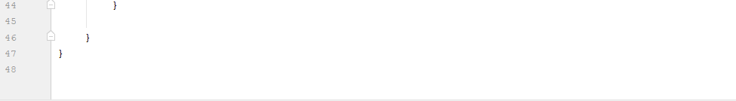

* 1. Signup helper (interface)

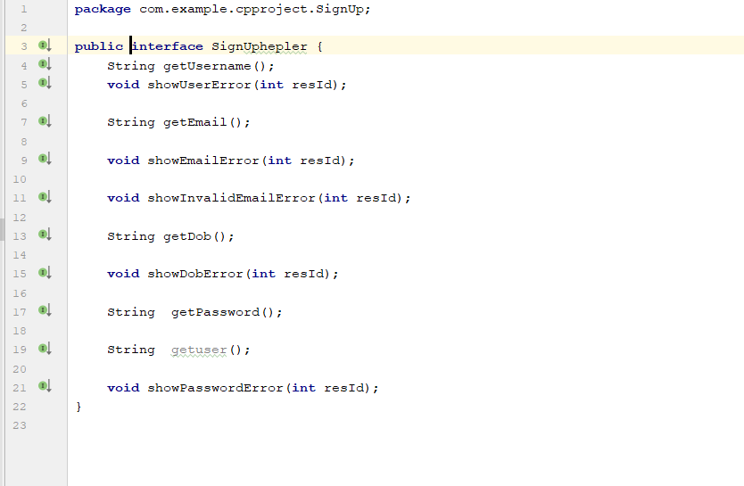

* 1. Signup helper services

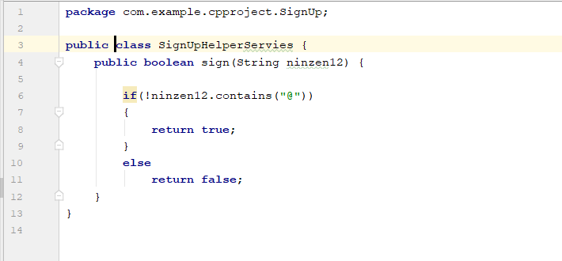

1. Add book
   1. Book helper activity

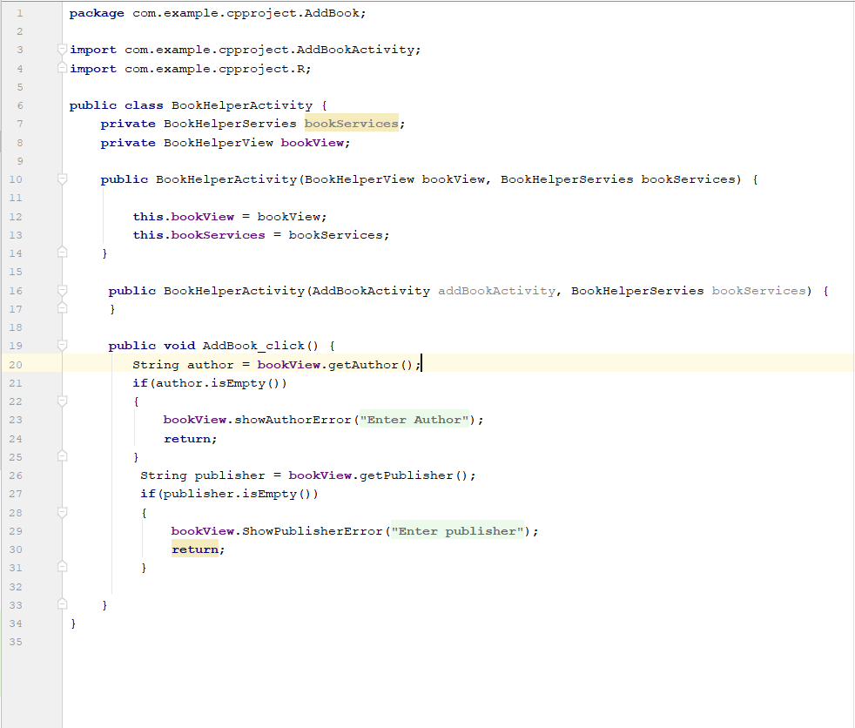

* 1. Book helper view

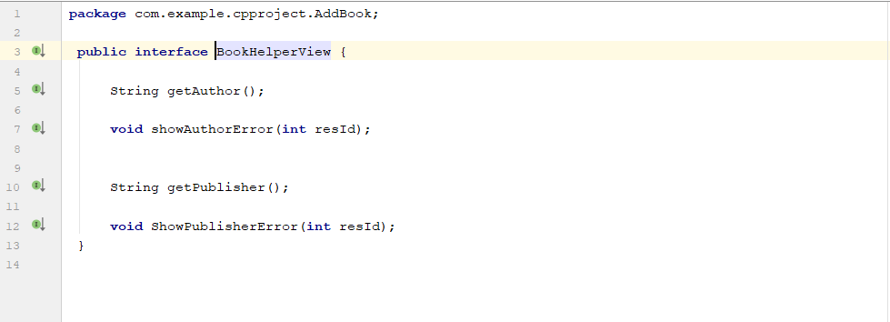

## 2. Black box testing.

Black box testing is known as the behavioral testing. The testing is done by the tester who test the software by the interface, design. This method attempts to find errors like Interface error, error in database, misfunctioning views etc.

The test plan of Book reading system for black box testing:

|  |  |  |  |  |  |
| --- | --- | --- | --- | --- | --- |
| S N | Test Case | Data | Expected | Actual Result | Date of testing |
| 1. | Show error message when username is null | Null | Error message to insert username | Error message to insert username | 2019/7/1 |
| 2. | Show error message when password is null | Username = ninzen  Password=null | Error message to insert password | Error message to insert password | 2019/7/1 |
| 3. | Open dashboard if password and username is correct | Username = ninzen  Password = password | Login successful | Login successful | 2019/7/1 |
| 4. | Show error message when password or username is invalid | Username = 123  Password =pass123 | Invalid username or password | Invalid username or password | 2019/7/1 |
| 5. | Download pdf file from online library | Click file | Downloaded | Downloaded | 2019/7/1 |
| 6. | Load all downloaded pdf files form online library | Retrieve data | Show all pdf files | Show all pdf files | 2019/7/1 |
| 7. | Open downloaded files | Click file | Open pdf | Open pdf | 2019/7/1 |
| 8. | Delete downloaded files | Click the delete button | Book has been deleted | Book has been deleted | 2019/7/1 |
| 9. | Add book | Click upload button | Book has been added | Book has been added | 2019/7/1 |
| 10. | Show error message when publisher is null | Publisher = null | Error message when publisher is null | Error message when publisher is null | 2019/7/1 |

1. Show error message when username is null.

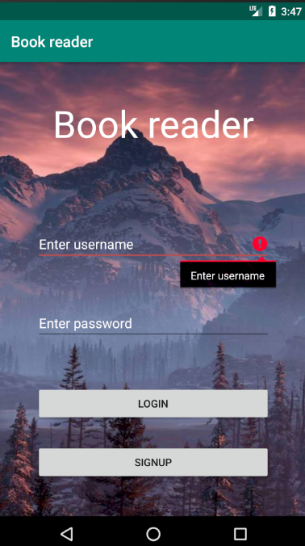

1. Show error message when password is null.

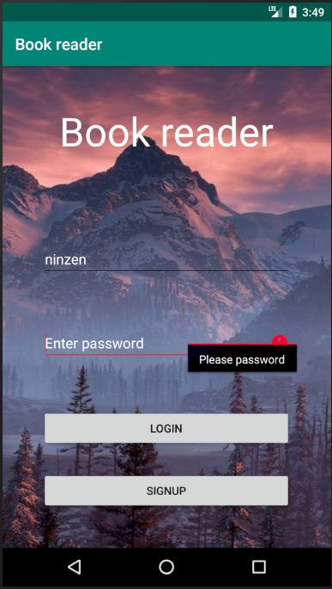

1. Open dashboard if password and username is correct.

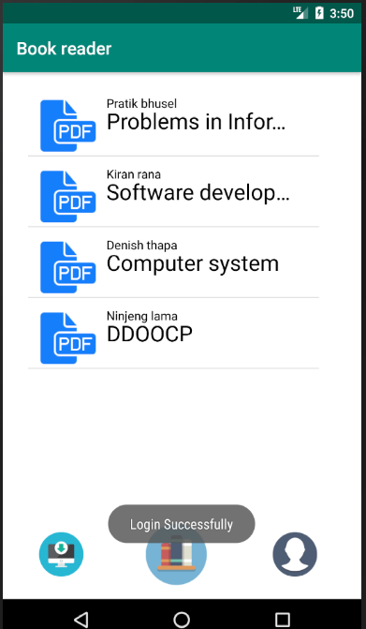

1. Show error message when password or username is invalid.

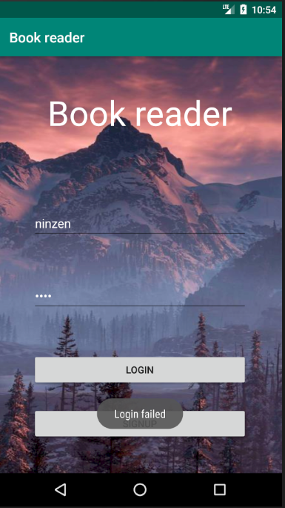

1. Download pdf file from online library.

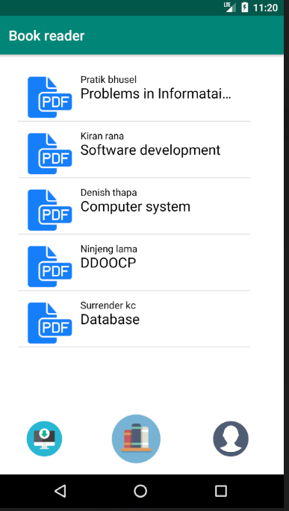

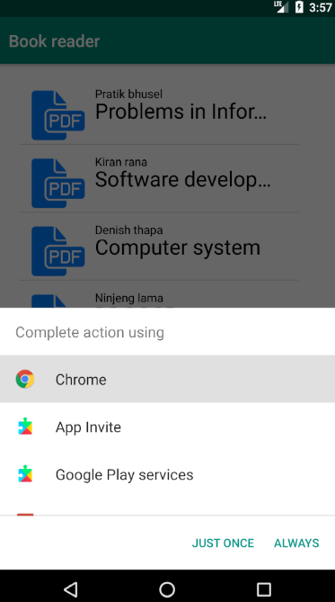

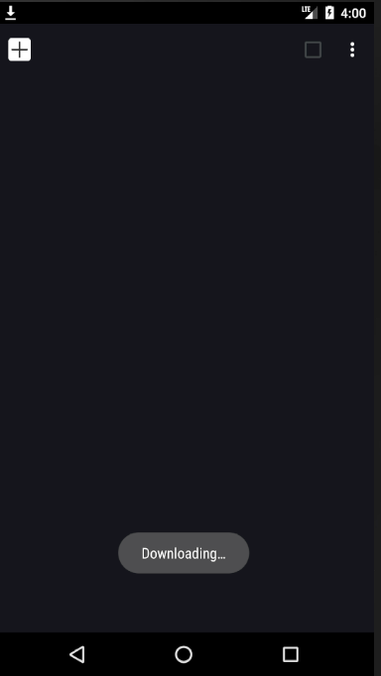

1. Load all downloaded pdf files form online library.

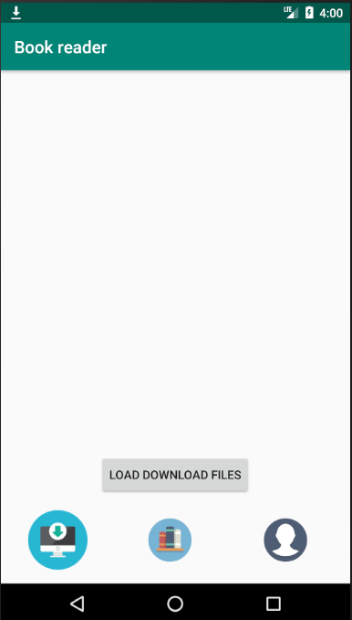

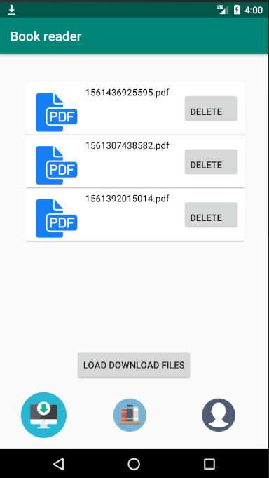

1. Open downloaded files.

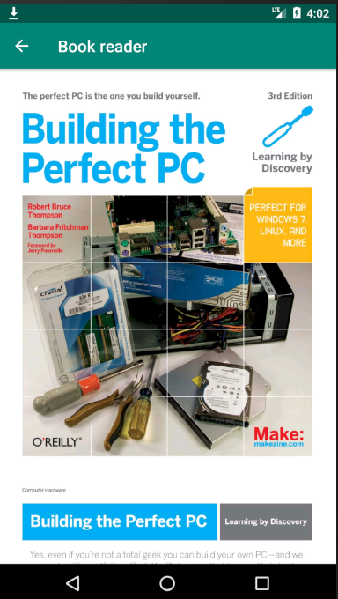

1. Delete downloaded files.

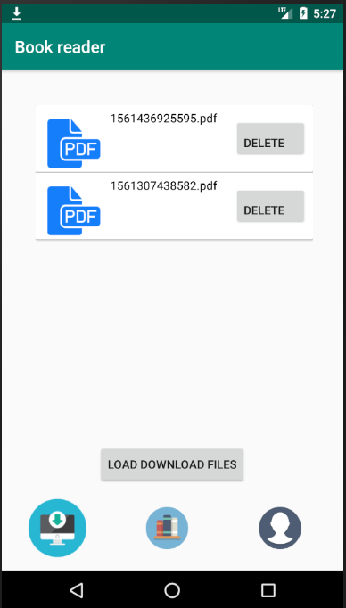

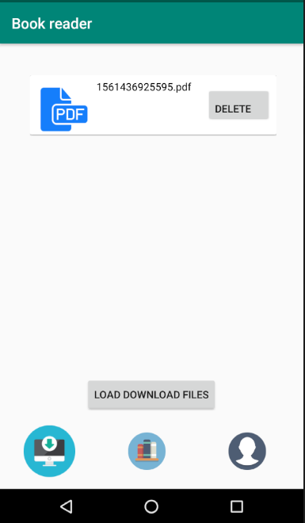

1. Add book.

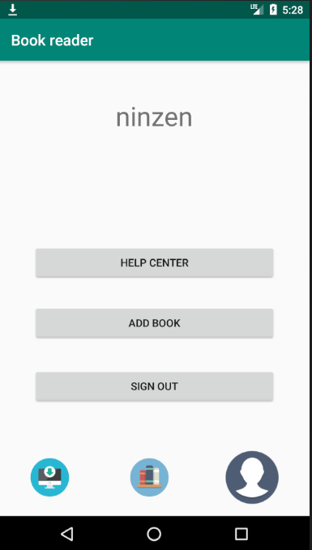

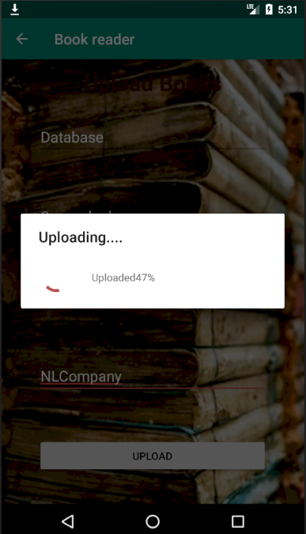

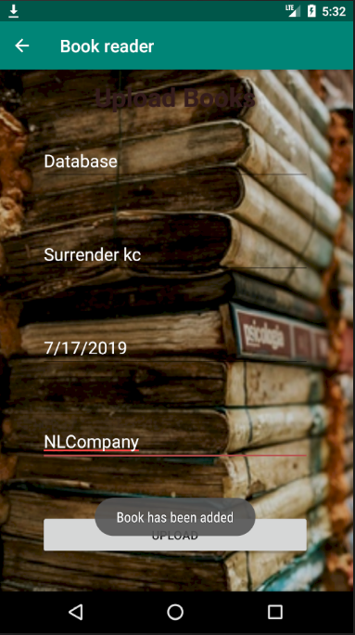

1. Show error message when publisher is null.

